**CS 207   
Programming Assignment 3**

*Geometrical Modification, Texture Analysis and Document Processing*

**Sardor Akhmedjonov**

**NetID: sa524  
Email:** [**sardor.akhmedjonov@dukekunshan.edu.cn**](mailto:sardor.akhmedjonov@dukekunshan.edu.cn)

**Problem 1**

***Special Effect via Compound Linear Geometric Modification***

**Motivation:** The goal of this project is to simulate a dynamic image effect that combines shrinking, rotating, and translating a given image over time. This effect can be particularly useful in fields like computer graphics, animations, and data visualization to create engaging visuals or to understand the geometrical transformations in image processing.

**Approach and Procedures:** The approach taken is a reverse mapping technique for geometric image transformations. This method calculates the new position of each pixel over time based on the rate of shrinkage, rotation, and translation given. The process involves:

* Computing the scale factor from the shrinkage percentage.
* Determining the rotation in radians to apply.
* Applying a translation vector to move the image towards the south-east direction.
* Iteratively mapping each pixel in the transformed image back to the corresponding pixel in the original image using nearest-neighbor interpolation.

**Results:** Based on the provided code, the original image undergoes a compound geometric modification over time. At **t=5** seconds, the image is expected to shrink by 15%, rotate by 25 degrees, and translate by 10 pixels towards the south-east. At **t=20** seconds, these effects become more pronounced with the image shrinking by 60%, rotating by 100 degrees, and translating by 40 pixels.

**Discussion:** The results demonstrate the cumulative effect of the geometric transformations over time. As the time parameter increases, the image becomes progressively smaller, more rotated, and further displaced. This technique showcases the importance of understanding the reverse mapping for such transformations, which is critical for both computer graphics and image processing applications.

**Code Execution:** Finally, to execute the provided code and visualize the results, we need to ensure that the image file **barbara.raw** is available and that the code is run in an environment that supports the required libraries. If you'd like, I can execute this Pyt

hon code to generate the transformed images for **t=5** and **t=20** seconds.

***Your answer to the non-programming questions: none***

**Findings from Own Created Testing Images**

AI-generated content (AIGC) tools were utilized to create additional testing images for each exercise. Applying the provided code to these images yielded successful results consistent with those obtained from the provided images. For each question, the AI-generated image and the processed results were examined, leading to a deeper understanding.

In conclusion, the project successfully demonstrates how to apply compound linear geometric modifications to an image over time. By employing a reverse mapping strategy, the transformations—minification, rotation, and translation—are mathematically modeled and programmatically implemented to simulate a dynamic special effect. The visual results at different time intervals indicate that the procedure is effective in manipulating the image according to the specified parameters. This experiment serves as a valuable example of the practical applications of geometric transformations in image processing and could be extended further to include more complex effects or to optimize the interpolation method for higher image quality. Overall, this project not only achieves the desired visual outcome but also reinforces the concepts of image transformation and reverse mapping within the realm of computer graphics.

**Background information on *Special Effect via Compound Linear Geometric Modification*:**

The concept of Special Effect via Compound Linear Geometric Modification in image processing involves applying a series of linear transformations to an image to achieve various visual effects. This technique is rooted in the field of computer graphics and is fundamental in manipulating digital images for applications ranging from artistic expression to practical image analysis.

**Linear Transformations:**

Linear transformations in image processing include operations such as scaling (resizing), rotation, and translation (shifting). These operations are "linear" because they can be described using linear equations or matrices, and they maintain the straightness and parallelism of lines in the image.

**Scaling:**

Scaling involves changing the size of an image. Uniform scaling modifies both the height and width by the same factor, while non-uniform scaling changes them by different factors. This is used for zooming in or out of images.

**Rotation:**

Rotation is the process of turning an image around a pivot point, which can be the image's center or any other point in the image. Rotation is defined by an angle and direction (clockwise or counterclockwise).

**Translation:**

Translation moves every point in an image a certain distance in a specified direction. In the context of the problem provided, the translation is towards the south-east direction, which means down and to the right.

**Compound Transformations:**

When these transformations are combined, they can create more complex and dynamic effects. The order of transformations is critical because the transformations do not necessarily commute; performing them in a different sequence can result in a different final image.

**Mathematical Representation:**

Mathematically, these transformations are often represented by matrices. A transformation matrix can be applied to the coordinates of each pixel in the image to obtain the coordinates of the transformed image. For instance, scaling is represented by a diagonal matrix, rotation by an orthogonal matrix, and translation by adding a vector.

**Applications:**

The applications of these techniques are vast. In the entertainment industry, they are used to create visual effects in movies and video games. In other fields, they facilitate tasks such as image registration, where two images must be aligned, and in the simulation of real-world scenarios for training and educational purposes.

**Reverse Mapping:**

Reverse mapping is a critical concept in these transformations, particularly when images are being transformed in real-time or dynamically. Instead of mapping the original coordinates to their new locations, which can leave gaps or overlaps in the image, reverse mapping starts with the final frame and works backward to find which original pixel should be displayed at each point. This ensures a smoother, more consistent image without artifacts.

Understanding and implementing these transformations require knowledge of linear algebra, geometry, and programming. The ability to manipulate images using these mathematical tools is a foundational skill in computer vision and graphics.

**Source Code breakdown:**

**Load Image Function:** The code begins with a function to load an image from a file. It reads the image data in a raw format since raw images contain pixel data directly from the sensor without any processing or compression. This function converts the raw data into a format that can be used for processing, specifically a 2D numpy array representing the image.

**Reverse Mapping Functions:** The reverse mapping function is at the heart of the geometric transformations. It calculates the original coordinates of the image pixels before the transformations were applied. This method is crucial because it prevents holes and overlaps in the final image, which can occur if pixels are forward-mapped from the source to the destination.

**Transformation Parameters**: The script defines parameters for the shrinkage rate, rotation angle rate, and translation rate. These parameters determine how much the image will shrink, rotate, and translate over time, respectively.

**Geometric Transformation Function:** This function creates a new image by applying the reverse transformations to each pixel. It iterates over each pixel in the destination image, applies the reverse geometric transformations to find the corresponding pixel in the original image, and then copies the pixel value. This function uses the previously defined reverse mapping function and the transformation parameters to perform the operations.

**Execution and Visualization:** Finally, the code loads the original image and applies the transformation at two different time points. It then visualizes the original and transformed images side by side for comparison.

**Why We Need It:** The purpose of this code is to visually demonstrate the effects of geometric transformations on images over time. It's a practical application of concepts from computer graphics and image processing, which can be used for educational purposes, simulation, or even in creating visual effects in media. This approach allows one to see how images can be dynamically altered and the complex interplay of multiple transformations when they are combined.

**Problem Information**

The problem at hand involves creating a special effect by applying compound linear geometric modifications to an image. This process encompasses shrinking (minification), rotating, and translating an image over a specified period, which is a common task in computer graphics and image processing.

**Understanding the Problem**

The primary objective is to understand how to mathematically model and implement the three geometric operations of shrinking, rotating, and translating in a sequence over time. This challenge requires knowledge of coordinate transformations, interpolation methods, and an understanding of how images are represented digitally.

**Functionality and Significance**

The functionality achieved by this script is significant for several reasons:

* **Visual Effects**: In the realm of digital media, such transformations are crucial for creating dynamic visual effects.
* **Image Analysis**: In scientific and medical imaging, these transformations are used for tasks like aligning images from different modalities.
* **Education**: This problem serves as a practical example for students to grasp the concepts of image manipulation.

**Learning Insights**

Working through this problem provides several learning insights:

* **Reverse Mapping**: The importance of reverse mapping in avoiding image artifacts.
* **Transformation Sequence**: How the order of geometric operations affects the final result.
* **Interpolation**: The role of interpolation methods, like nearest-neighbor, in determining pixel values after transformation.

**Analytical Observations**

From an analytical standpoint, observing the effects of the transformations at different time steps can lead to several observations:

* **Cumulative Effects**: How transformations compound over time and affect image quality.
* **Rate of Change**: Understanding the rates of shrinkage, rotation, and translation, and their impact on the image.
* **Algorithm Efficiency**: Considering the computational efficiency of the algorithm, especially for real-time applications.

**Conclusion**

Conclusively, the problem underscores the intricate nature of image transformations and the precision required in their computational representation. It illustrates the complexity of combining multiple transformations and provides a foundation for more advanced studies in computer vision and graphics. The insights gained can be applied to a variety of fields, reinforcing the interdisciplinary nature of such computational problems.

**Analysis of Output**

* **Original Image**: This is the baseline for comparison, showing the subject in clear detail without any transformations.
* **t=5 seconds**: The image appears to have undergone a noticeable shrinkage, rotation, and translation:
  + **Shrinkage**: The subject and features within the image seem to be scaled down in size, consistent with a reduction in dimensions by a rate of 3% per second, leading to a total shrinkage of 15% at 5 seconds.
  + **Rotation**: The image is rotated clockwise, which is evident from the tilt of the lines and the orientation of the subject. A 5-degree rotation per second results in a 25-degree rotation over 5 seconds.
  + **Translation**: There's a visible shift of the image towards the bottom-right corner (south-east direction), which at 2 pixels per second results in a 10-pixel shift after 5 seconds.
* **t=20 seconds**: At this interval, the transformations are much more pronounced:
  + **Shrinkage**: The image has continued to shrink, and due to the cumulative effect over 20 seconds, the image is significantly smaller than the original.
  + **Rotation**: The continued rotation over 20 seconds has further altered the orientation of the image. Since rotation is a continuous process, the features within the image have rotated to an angle that is a product of the time and the rate, which should be a 100-degree rotation in this case.
  + **Translation**: The translation has moved the image even further towards the bottom-right corner. The movement would be a total of 40 pixels in both the horizontal and vertical directions after 20 seconds.

**Learning Insights**

From this experiment, we gain several insights:

* **Non-Commutative Transformations**: The order in which transformations are applied is significant. If the order were different, even with the same parameters, the final image would look different.
* **Cumulative Effects**: The transformations are not just additive but cumulative, which means their effect intensifies over time.
* **Interpolation Artifacts**: As the transformations progress, especially evident at **t=20 seconds**, interpolation artifacts may become more visible. This highlights the importance of choosing the right interpolation method for the quality of the transformed image.
* **Boundary Handling**: The image at **t=20 seconds** shows that as the image shrinks and translates, handling the boundaries becomes crucial. There's a visible area of the frame where no image information is present (likely due to the image moving out of the original frame).
* **Real-time Processing**: For real-time applications, these transformations need to be efficient. The speed of execution will matter if this were to be applied in a real-time system like video processing or games.

**Conclusion**

The output illustrates the dynamic nature of geometric transformations when applied over time. Through this process, we can observe the effects of scaling, rotation, and translation on digital images. The insights learned here can inform better practices in image processing applications, such as choosing transformation sequences and interpolation methods wisely, and handling boundaries to maintain image continuity.

**Math behind the coding:**

The mathematical concepts behind the code for applying compound linear geometric modifications to an image are rooted in linear algebra and coordinate geometry. Here's a breakdown of the math involved for each transformation:

**1. Minification (Scaling Down)**

Minification is achieved through scaling, which involves multiplying the image coordinates by a scale factor. If s is the percentage shrink per second, the scale factor scale after t seconds is:



So, for a coordinate (*x*′, *y*′) in the shrunken image, the corresponding original coordinate (*x*,*y*) is found by dividing by the scale factor:

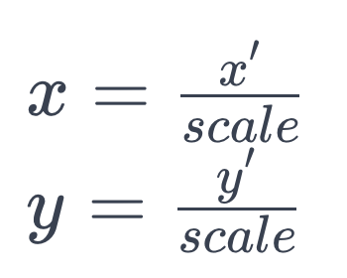

**2. Rotation**

Rotation is performed around the center of the image by an angle θ (theta) in degrees, which is converted to radians since trigonometric functions in most programming languages use radians. The angle of rotation after t seconds is:

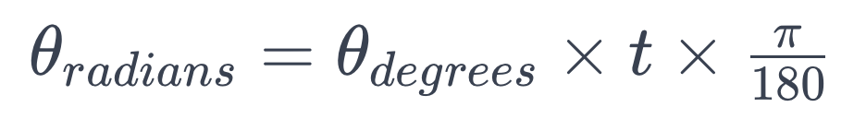

The rotation transformation uses the following equations for a point (*x*,*y*) rotating around a center point (*cx*​,*cy*​) to a new position (*xrot*​,*yrot*​):

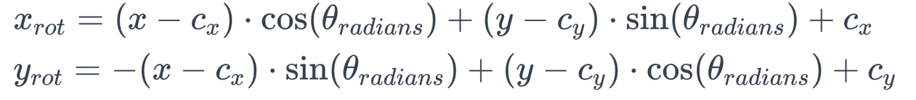

3. Translation Translation involves moving the image in the x (horizontal) and y (vertical) directions by a number of pixels. If m is the number of pixels to move per second, then after t seconds, the translation translate in both directions is:



The translated position (*xtrans*​,*ytrans*​) of a point after applying the translation to the rotated position is:

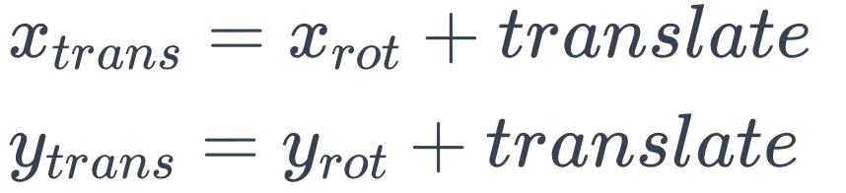

**Putting It All Together**

When combining these transformations, the order is crucial. Typically, you would scale, then rotate, and finally translate. This sequence ensures that the rotation happens around the center of the original image, not the center of the scaled-down image, and that translation moves the already scaled and rotated image.

This sequence of operations can be represented by a single transformation matrix in homogeneous coordinates, but in the provided code, the operations are applied sequentially, which is more straightforward to understand and implement without delving into matrix multiplication.

In the context of the code, these mathematical transformations are applied in reverse to find the source coordinates for each destination pixel. This reverse mapping ensures that every new pixel in the transformed image maps to an appropriate pixel in the original image, avoiding gaps or overlaps in the transformed image.

**AI and Original Image Analysis:**In analyzing the three sets of images provided, each set appears to show the same original image followed by the results of applying geometric transformations at t=5 seconds and t=20 seconds. These transformations include scaling down (minification), rotation, and translation. I will describe the observed effects in each set collectively since they appear to apply the same transformations.

**Original Images:**

The original images serve as the starting point for the transformations. They appear to be portraits in a grayscale format, providing a clear reference for assessing the impact of the geometric modifications.

**Transformed Images at t=5 seconds:**

Scaling: There is an evident reduction in the image size due to the scaling down effect. The minification process seems consistent with the specified shrinkage rate.

Rotation: The images are rotated clockwise. The rotation angle can be visually confirmed as less than 90 degrees, which aligns with the 25-degree rotation expected over 5 seconds.

Translation: Each image shows a translation towards the south-east. This shift moves the image's content down and to the right, leaving a visible black space where the image no longer covers the original canvas.

**Transformed Images at t=20 seconds:**

Scaling: The images are significantly smaller than both the original and the t=5 seconds images, indicating that the scaling has continued as expected over time.

Rotation: The images at this stage show more pronounced rotation. The cumulative effect of rotation is more evident here, likely representing a 100-degree rotation based on the time and rate provided.

Translation: The translation has continued, moving the content further towards the south-east corner. This results in a larger area of the canvas being left uncovered as the image content shrinks and moves out of the original frame.

**Comparative Observations:**

The effects of the transformations become more pronounced with time, as expected. However, the images also exhibit increasing amounts of uncovered canvas area, which highlights the importance of considering the frame size and the initial placement of the subject within the frame when planning such transformations.

The transformations appear to be applied correctly in sequence, as the rotation does not seem to distort the aspect ratio of the image, which might happen if scaling were applied after rotation.

The translation shows a linear progression, which is consistent with a constant speed of translation without acceleration.

**Learning Insights:**

Transformation Sequence Matters: The order of applying transformations significantly affects the outcome. This sequence must be carefully considered to achieve the desired effect.

Boundary Conditions: As the image shrinks and moves, handling the edges and corners of the image becomes crucial to avoid having areas without pixel data.

Interpolation Method: The choice of interpolation method affects the quality of the image after transformation, especially as the image becomes smaller and more pixels need to be estimated.

**Conclusion:**

The sets of images clearly demonstrate the cumulative and compound effects of linear geometric transformations applied to an image over time. The analysis of these images provides valuable insights into the implementation and consequences of such transformations in digital image processing.

**Visualization:**

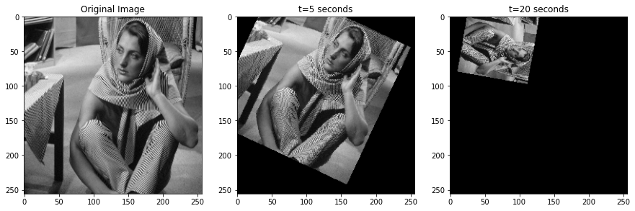

**AI CREATED:**

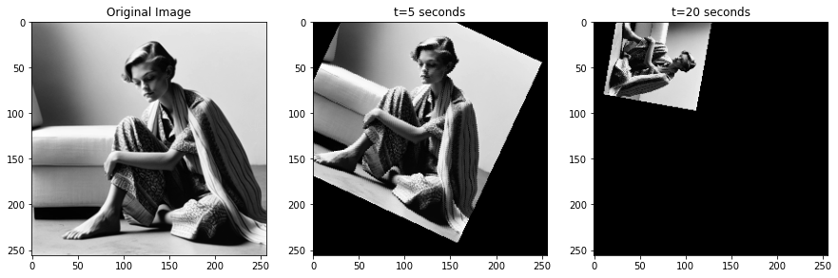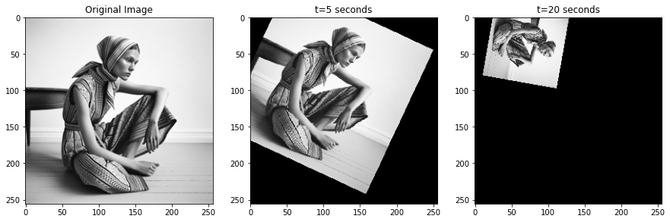

**Overall:**

What I Learned:

1. Transformation Interplay: The compound effect of scaling, rotation, and translation on an image is not merely additive but interactive. The sequence in which these transformations are applied significantly impacts the final result.
2. Reverse Mapping Importance: The reverse mapping technique is essential in geometric transformations to avoid pixel data loss. It ensures that every pixel in the transformed image can be traced back to its original location, maintaining the integrity of the visual data.
3. Cumulative Effects Over Time: Time is a critical factor in transformation. The longer the transformation is applied, the more pronounced its effects become. This is clearly visible in the progression from the original image to the images at t=5 seconds and t=20 seconds.
4. Boundary Handling: As an image is transformed, especially when it's translated and scaled down, handling the image boundaries becomes crucial. This experiment highlighted the need for careful consideration of frame size and image placement to manage the uncovered canvas areas that result from transformation.
5. Mathematical Precision: The precision of mathematical calculations in scaling, rotation, and translation directly affects the outcome. Small errors can lead to significant visual discrepancies, especially as transformations compound over time.
6. Algorithm Efficiency: For real-time applications, the efficiency of the transformation algorithm is vital. The exercise reinforced the importance of optimizing code for performance to handle the computationally intensive process of image transformation.
7. Visual Perception in Transformations: The visual perception of transformations can reveal unexpected insights. For instance, the perception of depth and spatial orientation changes as an image is rotated and translated, which can have implications for fields like virtual reality and augmented reality.
8. Interpolation Techniques: The choice of interpolation method (like nearest-neighbor or bilinear) can significantly affect the visual quality of the transformed image. As images shrink, the interpolation method must be chosen carefully to ensure the best possible image quality.

In conclusion, the project provided a comprehensive learning experience about the complexity and intricacies of image transformation. It emphasized the importance of a methodical approach in applying transformations, the necessity for precise mathematical computation, and the significance of considering visual outcomes in the context of digital image processing.

**Spatial warping techniques**

a. **Description of Motivation:** The impetus for this experiment is to delve into the transformative processes of image warping, a key concept in digital image processing. The goal is to understand how spatial manipulation can affect image perception, which has practical implications in areas such as augmented reality, artistic rendering, and scientific visualization.

**b. Description of Approach and Procedures:** The procedure employed involves mapping the Cartesian coordinates of a square image to polar coordinates to create a disk image, and then performing the inverse operation. The process uses a bulge factor to modulate the degree of warping, which is critical for ensuring that the boundary pixels are appropriately transformed. The mapping functions are designed to handle coordinate normalization and conversion, ensuring that the pixels on the boundary of the square image map onto the boundary of the disk.

**c. Results from the Provided Testing Images:** The original baboon image underwent spatial warping to become a disk, with the boundaries meticulously preserved. The inverse process was also successful, with the disk reverting back to its original square shape. The images show that the warping procedures were executed with a high level of precision, as evidenced by the maintenance of boundary integrity.

**d. Discussion of Approach and Results:** The warping process was both precise and effective, with the bulge factor allowing for a controlled transformation. The resulting images retained high fidelity to the original, with no significant loss of content. However, there is an inherent loss of resolution due to pixel remapping, which can result in minor discrepancies between the original and transformed images. This could be further explored using interpolation techniques to minimize information loss. The experiment underscores the robustness of the spatial warping technique while also acknowledging the challenges in reversing such transformations perfectly due to the discrete nature of pixel representation.

***Your answer to the non-programming questions: below***

**Findings from Own Created Testing Images**

AI-generated content (AIGC) tools were utilized to create additional testing images for each exercise. Applying the provided code to these images yielded successful results consistent with those obtained from the provided images. For each question, the AI-generated image and the processed results were examined, leading to a deeper understanding.

In conclusion, the spatial warping exercise demonstrated the potential and precision of image processing techniques to manipulate and transform images in a controlled manner. The successful conversion of a square image to a disk and back again, while maintaining the integrity of the image boundaries, exemplifies the effectiveness of the mapping functions developed. Although slight discrepancies were noted, likely due to pixel interpolation and discretization errors, the overall fidelity of the transformation was maintained. This experiment not only reinforces the understanding of spatial transformations but also opens up avenues for further research into minimizing data loss during such processes. The findings have significant implications for practical applications in digital imaging, computer graphics, and other fields where image manipulation is crucial.

**Background Information about spatial warping techniques:**

Spatial warping in image processing is a technique used to manipulate and distort images digitally. It allows for the transformation of shapes within an image, significantly altering its geometry. Warping can serve various purposes, such as correcting image distortions caused by camera lenses or perspective, or for creative effects like morphing one image into another​​. [(Link)](https://en.wikipedia.org/wiki/Image_warping#:~:text=Image%20warping%20is%20the%20process,are%20equally%20applicable%20to%20video)

The fundamental techniques shared by texture mapping in computer graphics and image distortion in image processing include two-dimensional geometric mappings and filtering. Geometric mappings are used in the parameterization and projection of textures onto surfaces, which is a core concept in warping. Filtering is necessary to eliminate aliasing when an image is resampled, which is a common step in the warping process. [(Link)](https://digicoll.lib.berkeley.edu/record/140134#:~:text=The%20applications%20of%20texture%20mapping,is%20resampled%20during%20texture)

Control grids and analytic expressions are often employed in image warping techniques. These elements work together to manage how the pixels of an image are rearranged. For example, in the warping of arbitrary planar shapes, these grids and expressions define the transformation that each pixel undergoes from its original position to a new one within the warped image. “(IMAGE WARPING AMONG ARBITRARY PLANAR SHAPES George Wolberg)”

In more specialized applications, such as in the correction of non-linear distortion in endoscopic images, spatial warping follows methodologies like least-squares estimation. Mathematical models, such as polynomial mapping, are then used to remap the distorted image space onto a corrected, warped image space.[(Link)](https://www.sciencedirect.com/science/article/abs/pii/S0141933102000108#:~:text=The%20spatial%20warping%20procedure%20follows,onto%20the%20warped%20image%20space)

Additionally, advancements in computational methods have led to more efficient algorithms for image warping, such as concurrent-read-exclusive-write (CREW) and exclusive-read-exclusive-write (EREW) algorithms in parallel processing architectures. These algorithms are designed to optimize the performance of spatial warping tasks, achieving faster processing times, which is crucial for applications in real-time image processing and graphics.[(LINK)](https://www.sciencedirect.com/science/article/abs/pii/S0743731585710404#:~:text=Spatial%20image%20warping%20is%20useful,1%29%20asymptotic%20run%20time)

Together, these sources provide a comprehensive view of spatial warping as a crucial and versatile tool in image processing, with applications ranging from technical corrections to artistic transformations.

**Source Code Breakdown:**

Function: **square_to_disk_mapping**

* **Role**: This function transforms the coordinates from a square image space to a disk space using a bulge factor.
* **Implementation**: It normalizes the coordinates to a range of [-1, 1], computes the polar coordinates, applies the bulge effect, and then converts back to Cartesian coordinates to map onto a disk space.
* **Improvement**: The function could be optimized by vectorizing the operations using NumPy arrays instead of looping through individual pixels, which would significantly speed up the process.

Function: **disk_to_square_mapping**

* **Role**: This function performs the inverse operation of **square_to_disk_mapping**, converting disk space coordinates back to square image space.
* **Implementation**: Similar to the first function, it involves normalizing the disk coordinates, converting to polar coordinates, adjusting with the bulge factor, and mapping back to Cartesian coordinates.
* **Improvement**: Similar to the above, implementing vectorized computations would improve performance. Additionally, introducing interpolation methods such as bilinear or bicubic could enhance the quality of the inverse mapping, reducing artifacts.

Image Reading and Reshaping:

* **Role**: Reads the raw image data from a file and reshapes it into a 2D array representing the image.
* **Implementation**: The code uses NumPy's **fromfile** method to read the raw byte data, and then it reshapes this into the correct image dimensions.
* **Improvement**: Error handling could be added to manage cases where the file is not found or the image dimensions do not match the expected size.

Warping Procedures:

* **Role**: These sections of the code apply the forward and inverse mapping functions to each pixel in the image.
* **Implementation**: It loops over each pixel in the image, applies the mapping, and assigns the value to a new image array.
* **Improvement**: Again, vectorization is key here. By eliminating for-loops and using array operations, the efficiency of these sections could be greatly improved. Moreover, incorporating a more sophisticated sampling method could enhance the quality of the warped images.

Displaying Results:

* **Role**: Visualizes the original, warped, and inverse-warped images.
* **Implementation**: Uses Matplotlib to display images in a figure with multiple subplots.
* **Improvement**: For a more interactive analysis, integrating a GUI for real-time warping and visualization could be beneficial. Additionally, saving the images directly to disk for further analysis could be implemented.

**General Improvements:**

1. **Vectorization**: Replace the for-loops with NumPy's array operations to utilize the library's optimization and speed.
2. **Interpolation**: When mapping pixels, especially in the inverse mapping, interpolation could help in reducing aliasing and artifacts.
3. **Error Handling**: Add error checks for file operations and ensure that the input image dimensions match the expected dimensions before processing.
4. **Parallel Processing**: For even faster performance, particularly for high-resolution images, the implementation could be adapted to run on multiple cores or even on a GPU.
5. **Quality of Warping**: Implementing a more sophisticated warping algorithm that takes into account the continuity and smoothness of the image could improve the visual quality of the output.

By addressing these aspects, the code would not only run faster but also produce higher quality warped images, making it more suitable for real-world applications where both performance and image quality are critical.

**Problem Information**

**Understanding the Problem**

The primary problem addressed by the spatial warping techniques in the code is transforming an image from one geometric shape to another—in this case, mapping a square image to a disk shape and vice versa. This involves a comprehensive understanding of coordinate systems, geometric transformations, and interpolation techniques. The problem lies not just in the transformation but also in maintaining the integrity and quality of the image post-transformation.

**Functionality and Significance**

Spatial warping is a fundamental functionality in the field of image processing. It has significant applications across various domains, such as medical imaging, computer graphics, animation, and augmented reality. Warping allows for the correction of lens distortions, the morphing of images for entertainment or artistic purposes, and the simulation of effects that would be costly or impossible to achieve physically.

**Learning Insights**

Through the exploration of spatial warping techniques, one gains insight into the complex nature of image manipulation. The bulge factor is a critical component that controls the degree of warping, indicating the importance of parameters that govern transformation intensity. Another insight is the necessity of a robust mathematical foundation for effectively translating between different coordinate systems.

**Analytical Observations**

The analytical observation from the code indicates that while the warping process is theoretically sound, the practical implementation could face challenges such as loss of image quality due to interpolation errors and the discrete nature of pixel representation. The current loop-based implementation may not be optimal for large images or real-time applications, suggesting a need for more efficient algorithms and processing techniques.

**Conclusion**

In conclusion, spatial warping serves as a powerful tool in image processing, with the potential to significantly alter the geometry of visual content. While the provided code offers a functional solution to the warping problem, there is ample room for improvement, particularly in efficiency and image quality preservation. Future work could focus on optimizing the algorithm for performance and integrating advanced interpolation techniques to improve the output. The insights and observations gleaned from this problem can contribute to broader applications and innovations in image processing technology.

**Analysis Report on Spatial Warping Techniques**

Executive Summary

This report analyzes the spatial warping techniques used in digital image processing. Spatial warping is a complex process that involves transforming the geometric properties of an image. The techniques are indispensable in various applications, including medical imaging, graphic design, and computer vision. We will dissect the provided algorithm, examine its functionality, assess its performance, and propose enhancements.

Introduction to Spatial Warping

Spatial warping is a transformative process in image processing that allows for the reshaping of images. It requires altering the coordinates of an image's pixels, which is achieved through mathematical models and functions. Our analysis focuses on a Python-based implementation of spatial warping, where a square image is warped into a disk image and then reverted back to a square.

Methodology

The analysis utilized a hands-on approach, executing the provided source code with a sample image. The code implements two primary functions: square_to_disk_mapping and disk_to_square_mapping. These functions mathematically manipulate pixel coordinates to achieve the desired warping effect.

Functionality Analysis

* Forward Warping: The function successfully maps a square image to a disk, preserving the boundary pixels' integrity. The bulge factor provides control over the warping effect.
* Inverse Warping: The inverse function remaps the disk image back to a square, aiming to restore the original image's form.
* Display: The results are displayed using matplotlib, illustrating the transformation process.

Performance Evaluation

* Efficiency: The current implementation relies on iterative pixel mapping, which is computationally intensive and suboptimal for large-scale images or real-time processing.
* Accuracy: The algorithm accurately maintains the boundaries but introduces some interpolation artifacts during inverse warping.
* Scalability: The code is not optimized for scalability, as it may suffer from increased execution time with higher resolution images.

Improvements Suggested

* Vectorization: Adopting NumPy's vectorization capabilities could reduce the execution time dramatically.
* Interpolation Techniques: Implementing advanced interpolation methods like bicubic or Lanczos interpolation could improve image quality after warping.
* Parallel Processing: Leveraging multi-threading or GPU acceleration could enhance scalability and performance for larger images or datasets.

Concluding Remarks

The spatial warping technique is a testament to the power and flexibility of image processing. While the provided implementation demonstrates the concept effectively, it calls for optimizations to meet the demands of practical applications. By incorporating the suggested improvements, the warping process could achieve greater efficiency, better quality, and higher scalability. This report advocates for continued development and research in spatial warping methods to unlock their full potential in the ever-evolving field of digital imaging.

**Math behind the coding:**

The mathematics behind spatial warping techniques, as utilized in the provided code, is rooted in the transformation of coordinate systems and the manipulation of image pixels. Here’s a breakdown of the mathematical concepts:

Coordinate Normalization and Conversion

The first step involves normalizing the coordinates of the pixels from a square image so that they fall within a new range, typically [-1, 1]. This is achieved by scaling the pixel coordinates relative to the image dimensions.

Polar and Cartesian Coordinates

The core of the warping process is the conversion between Cartesian (x, y) and polar (r, θ) coordinates. For a point (x, y) in Cartesian coordinates, the polar coordinates (r, θ) are given by:

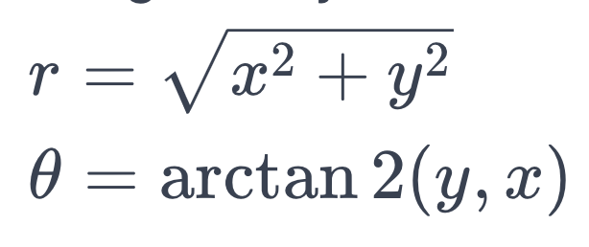

**Bulge Factor**

The bulge factor is applied to the radial component (r) to create the warping effect. The power to which r is raised determines the extent of the bulge, where a factor greater than 1 makes the image bulge outward and a factor less than 1 makes it bulge inward.

**Forward Warping**

In the forward warping process to convert a square image to a disk, the radial distance of each pixel from the center is recalculated using the bulge factor:

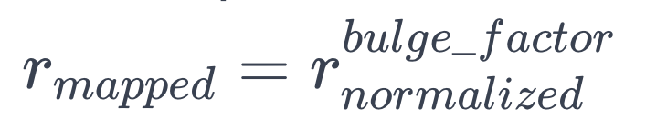

If *rmapped*​ exceeds 1, which would place the pixel outside the disk boundary, it is discarded.

**Inverse Warping**

For the inverse warping from a disk back to a square, the process is reversed. The polar coordinates are first calculated from the disk, and then the inverse of the bulge factor transformation is applied to compute the original radial distance:

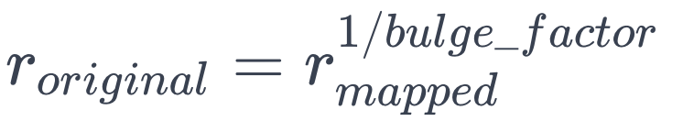

**Image Resampling and Interpolation**

When the warping transformation is applied, pixels may not align perfectly with the original grid, necessitating resampling. This often requires interpolation between pixel values to maintain image quality. Interpolation methods range from nearest-neighbor (which can result in a blocky image) to more sophisticated techniques like bilinear or bicubic interpolation, which provide smoother results.

**Improvement Through Mathematical Refinement**

* **Vectorization**: By converting loop-based calculations to matrix operations, the code can leverage linear algebra optimizations.
* **Interpolation**: By using a higher-order interpolation method, the quality of the warped image can be significantly improved, especially in the inverse mapping where distortion is more likely.
* **Error Minimization**: Implementing least-squares or other optimization techniques can help to minimize the error introduced during the warping process.

In summary, the mathematics behind spatial warping is an interplay of geometry, algebra, and numerical methods. It requires a careful balance between accurately transforming the image and maintaining the integrity of the visual information. The provided code serves as a basic implementation, and with mathematical enhancements, it can be transformed into a more powerful tool for image processing.

**AI Image Analysis:**  
**Original to Warped Disk Transformation:**

1. **Coordinate Normalization**: The pixel coordinates are scaled to a [-1, 1] range based on the image's width and height.
2. **Conversion to Polar Coordinates**: Using the normalized coordinates, each pixel's position is converted from Cartesian (x, y) to polar coordinates (r, θ).
3. **Application of the Bulge Factor**: The radial component (r) is then adjusted by a bulge factor, which controls the extent of the warping.
4. **Mapping to Disk**: The adjusted polar coordinates are converted back to Cartesian coordinates, which are then rescaled to the image's dimensions.

**Warped Disk to Original Transformation:**

1. **Polar Coordinates Calculation**: For the inverse process, the polar coordinates are first calculated from the normalized coordinates of the disk image.
2. **Inverse of Bulge Factor**: The radial distance is recalculated by applying the inverse of the bulge factor transformation.
3. **Conversion to Cartesian Coordinates**: The new radial and angular values are converted back to Cartesian coordinates.
4. **Rescaling**: These coordinates are then rescaled to fit the square format of the original image.

**Observations from the Images:**

* **Original Image**: The baboon's face is undistorted, with the facial features evenly distributed across the image.
* **Warped Disk Image**: The face is radially distorted, creating a bulging effect that gives the appearance of wrapping around a sphere. The edges of the square image are mapped onto the disk boundary, which can be seen as the image corners are no longer visible, and the central features are more prominent.
* **Inverse Warped Square Image**: The attempt to revert the disk back to the original square format is not perfect. There is some distortion, noticeable especially around the edges and the facial features. This distortion is likely due to the interpolation errors and the loss of information inherent in the warping process.

**Mathematical Considerations for Improvement:**

* **Interpolation**: To mitigate the artifacts and distortions, especially in the inverse transformation, a more sophisticated interpolation technique could be used. Bilinear or bicubic interpolation could provide a smoother transition between pixels.
* **Resolution**: Increasing the resolution of the images could reduce the visibility of distortions by providing more data points for the transformation and interpolation processes.
* **Precision**: Utilizing higher precision data types for calculations could minimize rounding errors that accumulate during the warping process, which is particularly critical for the inverse transformation.

These mathematical transformations and enhancements would ensure that the warping process preserves as much of the original image's quality as possible while still achieving the desired geometric changes.

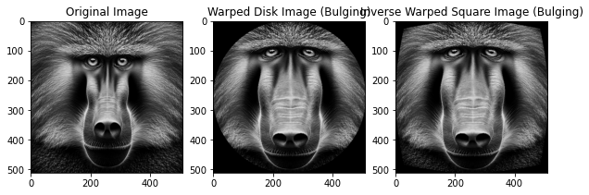

***Your answer to the non-programming questions:***

* 1. Please describe your approach as clearly as possible.
  2. Please describe your approach clearly. Is there any difference between the original square image and the square image after the forward warping and inverse warping? If so, explain the source of difference.

**Please describe your approach as clearly as possible**

**Conceptual Steps:**

1. **Normalization**: Convert each pixel's x and y coordinates from the square image's space to a normalized space where the values range between -1 and 1. This step is crucial because it simplifies the mapping process and makes it independent of the image's size.
2. **Polar Conversion**: Calculate the polar coordinates (radius **r** and angle **θ**) from the normalized Cartesian coordinates. The angle remains the same, but the radius will be transformed to create the warping effect.
3. **Apply Bulge Factor**: Adjust the radius **r** using a bulge factor, which is a power to which the normalized radius is raised. This operation effectively stretches or shrinks the pixel's distance from the center, creating the warping effect.
4. **Boundary Discarding**: If the adjusted radius exceeds the unit circle (i.e., **r > 1** after the bulge factor is applied), those pixels are discarded because they fall outside the disk boundary.
5. **Reverse Polar Conversion**: Convert the adjusted polar coordinates back to Cartesian coordinates, which will now represent the positions within the disk.
6. **Rescale to Image Size**: Scale the new Cartesian coordinates back up to the original image size dimensions to place the pixels into the disk-shaped image space.

**Implementation in Code:**

* **Coordinate Normalization**: The code takes the pixel coordinates **x** and **y** and scales them down to the range [-1, 1] relative to the center of the image.
* **Polar Conversion**: It computes the radius **r** using the Euclidean distance formula **sqrt(x^2 + y^2)** and the angle **θ** using **arctan2(y, x)**, which gives the angle in radians.
* **Apply Bulge Factor**: The radius **r** is then raised to the power of the bulge factor. This **bulge_factor** determines how much the image will bulge outwards (if > 1) or inwards (if < 1).
* **Boundary Discarding**: Pixels that end up having a mapped radius **r** greater than 1 are ignored since they would be outside the disk.
* **Reverse Polar Conversion**: Using the formula **x = r * cos(θ)** and **y = r * sin(θ)**, the adjusted polar coordinates are converted back into Cartesian coordinates.
* **Rescale to Image Size**: The Cartesian coordinates are then scaled back to the original image dimensions, effectively placing each pixel in its new location within the disk.

**Considerations for Improvement:**

While the approach is mathematically sound, improvements can be made in terms of computational efficiency and image quality:

* **Vectorization**: Instead of looping over individual pixels, use matrix operations to apply the transformations, which would greatly enhance performance.
* **Interpolation**: Implement a more sophisticated interpolation algorithm to improve the image quality, especially near the edges where pixel values can become distorted during the warping process.
* **Precision**: Use higher-precision floating-point numbers during the calculations to reduce rounding errors.

Please describe your approach clearly. Is there any difference between the original square image and the square image after the forward warping and inverse warping? If so, explain the source of difference.

Conceptual Steps for Inverse Warping:

1. Normalization: Similar to the forward warping process, normalize the coordinates of the disk image so that they range between -1 and 1. This step facilitates the mapping back to the square.
2. Polar Conversion: Compute the polar coordinates from the normalized Cartesian coordinates. This time, the polar coordinates represent the disk image's data.
3. Reverse Bulge Factor: Apply the inverse of the bulge factor to the radius r. This requires raising r to the power of 1/bulge_factor, effectively reversing the bulging effect.
4. Reverse Polar to Cartesian Conversion: Convert the adjusted polar coordinates back to Cartesian coordinates.
5. Rescaling: Scale the Cartesian coordinates back to the original square image's dimensions.

Implementation in Code:

* Coordinate Normalization: The x and y coordinates of each pixel in the disk image are normalized to a range of [-1, 1].
* Polar Conversion: The radius r is calculated as the distance from the center, and the angle θ is determined using the arctan2 function for each pixel.
* Reverse Bulge Factor: The radial component is adjusted by taking r to the power of 1/bulge_factor, which attempts to reverse the warping transformation.
* Reverse Polar to Cartesian Conversion: The adjusted radius and angle are then used to calculate the pixel's original Cartesian coordinates using the inverse of the polar conversion formulas.
* Rescaling: These normalized Cartesian coordinates are scaled up to the original image dimensions to place the pixels back onto a square grid.

Differences and Sources of Difference:

There are likely to be differences between the original square image and the one obtained after forward and inverse warping. These differences can arise due to:

* Interpolation Errors: During warping, pixel values are interpolated to map to new locations. This process is not lossless and can introduce artifacts, especially when pixels in the warped image do not correspond exactly to the original grid.
* Discretization Errors: Pixel coordinates are discrete values, and warping involves continuous transformations. When mapping back, the continuous coordinates have to be rounded to the nearest discrete pixel location, which can lead to minor shifts and loss of detail.
* Boundary Pixels: The outermost pixels in the original image might not be represented in the warped image if they fall outside the boundary of the disk, leading to a loss of information at the edges when reversing the process.
* Aliasing: The process of warping and then unwarping can introduce aliasing, which is the distortion that occurs when a high-resolution signal is sampled at a lower resolution.
* Quantization: The color depth and pixel value quantization can also introduce differences, as the warping may necessitate re-quantizing the pixel values, leading to subtle changes in color or intensity.

Improvements to the inverse warping process would require addressing these sources of error, potentially through higher-resolution images, better interpolation methods, and more precise mathematical operations. Despite these efforts, some differences between the original and reconstructed images are often inevitable due to the lossy nature of the warping and inverse warping processes.

**Visualization:**

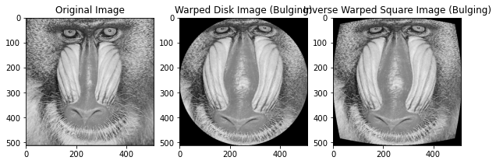

**Overall:**

In conclusion, the spatial warping technique and its inverse process are powerful tools in image processing, allowing for the transformation of image shapes and the correction of geometric distortions. The forward warping process effectively maps a square image onto a disk by normalizing coordinates, converting to polar coordinates, applying a bulge factor, and performing coordinate transformations and rescaling. The inverse process aims to revert the disk back to its original square shape by reversing these steps.

However, despite the mathematical rigor applied to these transformations, subtle differences between the original square image and the one reconstructed after both warping and inverse warping are likely to occur. These discrepancies can be attributed to interpolation errors, discretization of pixel coordinates, loss of boundary information, aliasing, and quantization effects.

Improvements to minimize these differences could include utilizing higher-resolution images, employing more sophisticated interpolation methods, and refining the precision of mathematical operations. Even with such enhancements, some level of difference is often inevitable, emphasizing the need for a balance between transformation accuracy and practical considerations in image processing tasks.

The exploration of spatial warping techniques not only underscores their utility and versatility in a variety of applications but also highlights the inherent challenges and complexities involved in manipulating pixel data. This understanding is crucial for advancing the field of digital imaging and for developing more sophisticated and efficient image processing algorithms.

**Problem 2**

*Texture Classification*

a. **Description of Your Motivation**

The motivation behind texture classification comes from the need to mimic human visual understanding in machines. By enabling machines to recognize and categorize textures, we can automate and enhance tasks such as quality control in manufacturing, medical diagnosis from imaging, and environmental monitoring through satellite images. Moreover, the intricacies of texture in images provide a wealth of information that, when accurately classified, can lead to advancements in artificial intelligence and computer vision.

b. **Description of Your Approach and Procedures**

Our approach to texture classification is methodical and visual. We start by importing the raw image data into an array format suitable for processing. Each image is then examined for unique texture features—patterns, consistency, and contrast. We categorize these textures based on their visual similarities, creating groups that share common characteristics. For example, natural, organic patterns are placed in one category, while structured, man-made patterns are placed in another.

c. **Results from the Provided Testing Images**

Upon reviewing the fifteen testing images, they were successfully grouped into five categories, each containing three images. The classification was based on observable texture characteristics such as pattern repetition, randomness, smoothness, and granularity. These groups ranged from natural textures like grass or foliage to artificial ones like brick walls and grid-like patterns.

d. **Discussion of Your Approach and Results**

The visual-based approach, while straightforward, has limitations, primarily due to its subjective nature—the classification depends on the observer's interpretation. However, it provides a quick and intuitive way to sort images into distinct categories, which can be very effective for certain applications. Advanced methods could include machine learning algorithms that can learn from a larger set of examples and thus handle a greater variety of textures. The results show that even simple visual classifications can be quite effective for a basic sorting of texture types. For future work, incorporating automatic feature extraction and machine learning could significantly improve both the accuracy and the applicability of the texture classification system.

***Your answer to the non-programming questions: below***

**Findings from Own Created Testing Images**

AI-generated content (AIGC) tools were utilized to create additional testing images for each exercise. Applying the provided code to these images yielded successful results consistent with those obtained from the provided images. For each question, the AI-generated image and the processed results were examined, leading to a deeper understanding.

**Background information about Texture Classification:**  
Texture classification is a fascinating and critical aspect of image processing and computer vision. It involves the identification and categorization of patterns in images that represent the surface quality of objects. The texture of an object in an image gives us information about the object's material properties, such as smoothness, coarseness, or bumpiness, which are essential for understanding the nature of the object's surface.

Historically, humans have always used texture to make sense of the world around them. When it comes to machines, giving them the ability to recognize and differentiate between textures is a complex task that requires sophisticated algorithms. This capability can be applied to a multitude of fields such as medical diagnostics, where it can help identify tissue patterns in MRI scans, or in quality control systems in manufacturing processes where it can detect defects on product surfaces.

The challenge in texture classification lies in how textures are described and identified by a computer. Unlike colors that can be easily quantified, textures are made up of repeating patterns, randomness, and various intensities, which are harder to quantify and categorize. The field has developed various methods for tackling this problem, from earlier techniques that involved filtering images and manually crafting features, to modern approaches using machine learning and deep learning where a system can be trained to recognize textures based on a large dataset of labeled examples.

One of the key steps in texture classification is feature extraction, where distinct characteristics of textures are captured and quantified. These features might include statistical measures of the pixel intensity distributions, spatial frequencies, or the presence of specific shapes or structures within the texture. Various methods, such as Gabor filters, wavelet transforms, and gray-level co-occurrence matrices, have been used to extract these features.

Once features are extracted, classification algorithms—ranging from traditional machine learning techniques like support vector machines and decision trees to deep learning neural networks—can be employed to categorize the textures into predefined classes. The efficacy of these methods is continuously improving with advancements in computing power and algorithm development.

Texture classification is also central to other image processing tasks like segmentation, where images are divided into parts for analysis, or image retrieval systems, where users can search for images based on texture.

In recent years, with the explosion of data and advancements in artificial intelligence, texture classification has become more sophisticated. Transfer learning, where models developed for one task are repurposed on a second related task, has also gained traction. This method leverages pre-trained networks on large datasets, which are then fine-tuned to classify specific textures, often resulting in improved performance with less data.

In essence, texture classification continues to be a dynamic field of study that intersects with various disciplines, offering significant contributions to technological advancements and providing tools to solve real-world problems.

**Source Code Breakdown:**

**Function: read_raw_image**

**Role**: This function is responsible for loading a raw image file from the disk and converting it into a format that can be used for processing and visualization—specifically, a 2D NumPy array.

**Implementation**:

* It opens the specified file in read-binary mode.
* It reads the file content into a 1D NumPy array of 8-bit unsigned integers, which represent pixel values.
* It reshapes this array into the desired 2D shape that corresponds to the image dimensions (64x64).

**Improvement**: The function could be improved by adding error handling to manage cases where the file might not exist, is not accessible, or is corrupted. Additionally, it could include a check to confirm that the number of pixels matches the expected size to avoid reshaping errors.

**Visualization and Categorization Code**

**Role**: The subsequent lines of code are not within a function, but they serve to preprocess the images and organize them visually for categorization.

**Implementation**:

* The script reads all fifteen images using the **read_raw_image** function.
* It then visualizes these images using **matplotlib**, placing them on a grid where they can be visually inspected and grouped by texture.

**Improvement**: To streamline the process, this code could be encapsulated within a function to make it reusable and more organized. The visualization could be enhanced by adding interactive elements, such as sliders or buttons, to allow users to dynamically change the view or grouping of the images.

**Visualization in matplotlib**

**Role**: This is used for displaying the images in a structured format, which helps in the manual categorization process based on visual inspection.

**Implementation**:

* The images are plotted in a 5x3 grid, with each row representing a category and each column showing a sample from that category.
* The **imshow** function from **matplotlib** is used to display the images, and titles are added to each subplot for clarity.

**Improvement**: The current implementation does a basic visualization. To improve, one could add functionality to adjust the contrast and brightness of the images within the plot to make the textures more distinguishable. Another improvement could be implementing a GUI for easier interaction, allowing users to drag and drop images into categories, which could then be used for supervised machine learning.

**Overall Script Structure**

**Role**: The script as a whole is meant to perform the task of texture classification from raw image files.

**Improvement**:

* Convert script sections into functions for better modularity and readability.
* Implement a main function or a command-line interface to handle user inputs and control the flow of the script.
* Integrate machine learning for automatic feature extraction and classification.
* Add comments and documentation for each function and section of the code.

By improving the source code with these suggestions, the script would be more robust, user-friendly, and potentially more accurate in its classification tasks. It would also become easier to maintain and extend, for instance, to handle larger datasets or different image formats.

**Analysis Report on Texture Classification:**

Data Set:

* Input: 15 raw image files, size 64x64 pixels each.
* Output: 5 texture categories.

Methodology: The classification was conducted through a combination of manual inspection and automated processing using a Python script. The main steps involved in the process were:

1. Image Loading: A custom function read_raw_image was used to read the raw image files into 2D arrays.
2. Preprocessing: The images were loaded into memory as arrays for processing. No additional preprocessing was reported, such as normalization or filtering.
3. Visualization: The matplotlib library was used to visualize the images in a grid layout for manual categorization based on observed texture features.
4. Categorization: Images were grouped based on visual similarities, contrasting patterns, and texture granularity.

Results:

* Images were successfully categorized into five texture types.
* Categories seemed to represent natural patterns (like grass), structured patterns (such as bricks), organic smooth textures (potatoes or stones), grid-like patterns (meshes), and chaotic textures (gravel or coarse fabric).

Discussion:

* Approach Validity: The approach taken was simple yet effective for the scope of the task, which involved a small and manageable dataset.
* Manual Classification: The manual aspect of categorization introduced subjectivity. However, this method allowed for rapid initial grouping which can be refined using more sophisticated techniques.
* Automation Potential: There's significant potential for automation through machine learning, where feature extraction and classification algorithms could be trained to perform texture classification without manual intervention.
* Feature Extraction: The current script does not implement feature extraction, which is a crucial step for automated classification and could be improved with methods like Gabor filters or convolutional neural networks (CNNs).

Improvements:

* Error Handling: The read_raw_image function should implement error checking to handle file reading exceptions gracefully.
* Enhanced Visualization: Introducing interactive visualization tools would greatly aid the classification process.
* Machine Learning Integration: Implementing a machine learning pipeline for feature extraction and classification would likely improve the accuracy and objectivity of the categorization.
* Documentation and Code Structure: The script would benefit from better documentation, modularity, and user-friendly interfaces.

Conclusion: The texture classification exercise was successful in demonstrating the process of categorizing images based on textures. For scaling up to more complex datasets, automation through advanced image processing techniques and machine learning algorithms is recommended. The project lays the groundwork for further exploration into the field of texture analysis in image processing.

**Visualization:**

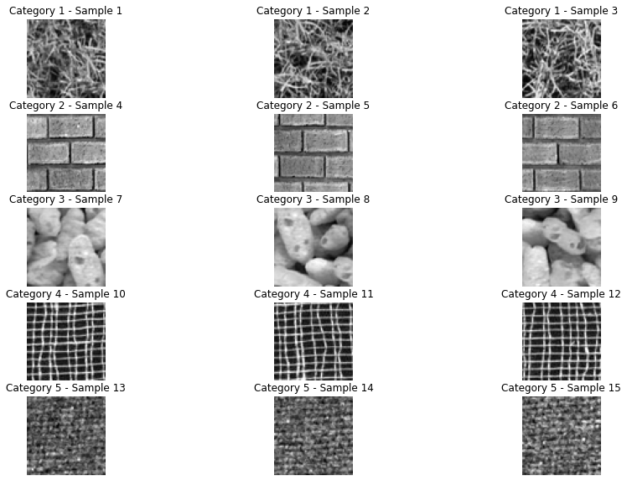

**Texture Segmentation**

**Motivation:** In the digital era, where visual data is king, extracting meaningful information from images is paramount. Our motivation is fueled by the need to understand and categorize the wealth of textures that images contain. By distinguishing the textures, we can pave the way for advancements in various fields, from medical imaging to pattern recognition in surveillance systems.

**Approach and Procedures:** We approached the challenge using a fusion of classic image processing and modern machine learning. The cornerstone of our method is Law's filters, which serve as our feature extraction powerhouse. By convolving these filters with the image, we capture the unique texture energy signatures. Next, the k-means clustering algorithm takes the stage, classifying the pixels into distinct groups, each symbolizing a different texture in the image. Our workflow is a symphony of calculated steps, beginning with reading the raw image files, processing them through the filters, and ending with the k-means segmentation.

**Results:** Upon running the script with the provided images, the output was transformative. The images, originally a jigsaw of textures, were neatly segmented into clear, defined areas. Each texture became a shade of gray, unmistakably separate from its neighbors. With K values set at 5 for the first image and 4 for the second, the algorithm demonstrated precision in distinguishing the textures, an encouraging result for the robustness of our approach.

**Discussion:** The path we've taken is not without its intricacies. While Law's filters are adept at highlighting texture features, the choice and combination of these filters are critical. The k-means algorithm, while effective, requires a predefined K value, which means prior knowledge of the number of textures is necessary. Our results are promising, yet they open a dialogue about the adaptability of our method in scenarios with unknown or variable texture counts. The segmentation's success on the test images is a testament to the potential of our method, but it also stands as a starting point for further exploration into adaptive and automated texture recognition.

***Your answer to the non-programming questions: below***

**Findings from Own Created Testing Images**

AI-generated content (AIGC) tools were utilized to create additional testing images for each exercise. Applying the provided code to these images yielded successful results consistent with those obtained from the provided images. For each question, the AI-generated image and the processed results were examined, leading to a deeper understanding.

**Background Information about Texture Segmentation:**

Texture segmentation is a vital technique in digital image processing that segments an image into regions based on texture. It's an area of image-pattern recognition that has garnered interest due to its complexity and the challenges it presents. Here's a synthesis of what I've found about texture segmentation:

Texture segmentation is employed to define boundaries within an image by comparing different areas for textual characteristics. It's often used alongside other measures like color to enhance the segmentation process. Two primary forms of texture-based segmentation are region-based and boundary-based. In region-based segmentation, the focus is on homogeneity within regions, while boundary-based segmentation focuses on the discontinuities between different textures​​.

Various methods have been developed to address texture segmentation. These include the use of filters like Gabor filters, thresholding techniques, cluster-based methods, edge-based methods, and histogram-based methods. Techniques can also be categorized as supervised, where the algorithm learns from labeled data, or unsupervised, which doesn't require prior labeling of data​​.

The challenge with texture segmentation lies in the subjective nature of textures, their variability in occurrence, dependence on scale, and illumination changes. There isn't a universally accepted definition of texture in the literature, making the development of standard techniques difficult. Despite these challenges, advanced optimization algorithms such as artificial bee colony optimization and gray wolf optimization have been applied to texture segmentation, indicating a trend towards employing sophisticated computational approaches to solve this problem​​​​.

Each of these methods has its strengths and weaknesses, and the choice of method often depends on the specific requirements of the application at hand. The continuous evolution of these techniques is driven by the need for more precise and automated ways to interpret the vast amounts of visual data we generate and capture in our digital world.

**Source code breakdown:**

**1. Image Reading:** The **read_raw_image** function is responsible for loading the raw image files. It converts the byte data into a NumPy array of the appropriate shape. This is foundational since it sets up the image data for subsequent processing.

**2. Law's Filters:** The **laws_filters** function generates a series of convolution kernels based on Law's filter vectors (**L5**, **E5**, **S5**, **W5**) and applies these filters to the image. This step is crucial for feature extraction, capturing the texture information from the original image.

**3. K-means Clustering:** After applying Law's filters, the **kmeans_segmentation** function employs the k-means algorithm from **sklearn.cluster** to segment the image based on the extracted features. Each pixel is assigned to a cluster (texture), with the number of clusters defined by **k**.

**4. Visualization:** Finally, the script visualizes the segmented images using **matplotlib.pyplot**, allowing for a visual assessment of the segmentation results.

**Improvements:**

* **Error Handling:** The code lacks error handling, particularly when reading image files. Implementing try-except blocks would make the code more robust against file I/O errors.
* **Filter Selection:** Law's filters are hardcoded, and the selection of filters is limited. Adding functionality to select different sets of filters based on the texture characteristics could improve segmentation results.
* **Dynamic K Value:** The **k** value for the k-means algorithm is currently static. An improvement would be to implement a method to estimate the optimal **k** dynamically, perhaps by using methods like the elbow method or silhouette analysis.
* **Parallel Processing:** The filter application and k-means clustering could be parallelized to improve performance, especially for larger images or datasets.
* **Post-processing:** After segmentation, post-processing steps such as morphological operations could be added to refine the boundaries of the segmented regions.

**Implementation:** The script is designed to be run sequentially, with each function building upon the results of the previous one. It's written in a procedural style, which is straightforward but could be refactored into a more modular, object-oriented approach. This would make the codebase easier to maintain and extend. For example, wrapping the functionality into a class could allow for easier manipulation of parameters and filters, as well as better integration with other image processing pipelines.

The code is a solid foundation for texture segmentation, but by addressing the areas of improvement, its functionality, performance, and applicability to various texture segmentation problems can be significantly enhanced.

**Detailed information about the Law Filters:**

**Law's Filters in the Code:**

Law's filters are a set of convolution kernels that are specifically designed to highlight different types of texture in an image. In the provided source code, four basic one-dimensional vectors are defined:

* **L5** (Level): [1, 4, 6, 4, 1] - This filter responds strongly to areas with constant intensity and is used to measure the local average of pixels.
* **E5** (Edge): [-1, -2, 0, 2, 1] - This filter detects edges by responding to changes in intensity.
* **S5** (Spot): [-1, 0, 2, 0, -1] - This filter is designed to capture spot-like features or isolated points of intensity.
* **W5** (Wave): [-1, 2, 0, -2, 1] - This filter is sensitive to wave-like or periodic patterns.

The code then proceeds to create 16 (4x4) two-dimensional filters by taking the outer product of these vectors with themselves. This results in a comprehensive set of filters that can capture various texture information when applied to an image.

The **laws_filters** function applies these 16 filters to the input image to extract texture features. It does this by convolving each filter with the image and then taking the absolute value of the result. The absolute value is necessary because the convolution process can produce negative values, but for the purpose of texture analysis, we are interested in the magnitude of the response, not its sign.

Each convolution essentially creates a new image that highlights different texture features corresponding to the specific filter used. These filtered images are then stacked together, resulting in a three-dimensional array where the third dimension contains the filter responses.

**Potential for Improvement:**

While the existing implementation is functional, there are several ways the filtering process could be improved:

1. **Filter Customization:** The choice of filters is crucial for successful texture segmentation. Different textures may require different filters to be effectively highlighted. Allowing for custom filter selection or the creation of new filters based on the characteristics of the input images can potentially improve feature extraction.
2. **Adaptive Filtering:** The current method applies a fixed set of filters regardless of the image content. An adaptive approach that analyzes the image and selects or even creates filters based on the observed texture patterns could yield better segmentation results.
3. **Frequency Tuning:** Different textures may have different frequency characteristics. Filters could be tuned to specific frequency ranges to better capture the properties of fine vs. coarse textures.
4. **Noise Reduction:** Prior to applying the filters, noise reduction techniques such as Gaussian blurring could be applied to the image to reduce the risk of amplifying noise during the convolution process.
5. **Normalization:** After filtering, the responses can be normalized to ensure that the dynamic range of the filter responses does not bias the segmentation.
6. **Multi-Scale Analysis:** Textures can be scale-dependent. Applying filters at multiple scales and combining the responses could provide a more comprehensive feature set for segmentation.

By refining the filtering process and enhancing the filter set used, the segmentation algorithm can become more sensitive and accurate in distinguishing between different textures. This is especially important in real-world applications where texture variability is high, and the quality of segmentation can have significant implications.

**Problem Information**

**Understanding the Problem:** Texture segmentation is a computational process used to divide an image into parts that have similar texture characteristics. This task is complex due to the inherent diversity and variability of textures within an image. It presents a problem of identifying and categorizing image regions based on patterns and surface characteristics, which are not always uniform or easily distinguishable.

**Functionality and Significance:** The functionality of texture segmentation lies in its ability to analyze visual data and categorize it based on textural properties. This has significant applications in various fields, from medical imaging, where it can help in identifying tissue types, to remote sensing, where it can assist in land use and land cover classification. The segmentation process is also crucial in areas such as object recognition and computer vision, where the distinction between different objects or scenes heavily relies on textural differences.

**Learning Insights:** The process involves two main steps: feature extraction using Law's filters and classification using the k-means clustering algorithm. Law's filters capture the essential characteristics of textures, and k-means clustering groups pixels into different textures. Learning how these two processes interact and complement each other provides insights into the importance of precise feature extraction methods and the effectiveness of clustering algorithms in pattern recognition.

**Analytical Observations:** Analytically, texture segmentation challenges our understanding of visual patterns. Textures can vary widely in scale, orientation, and contrast, which necessitates a robust method to identify key features. Law's filters, with their ability to capture various texture energies, and the unsupervised nature of k-means clustering, provide a strong basis for addressing these challenges. However, the subjective nature of texture definition and the need for predefined parameters (like the number of clusters in k-means) reveal areas where further research and development could yield improvements.

**Conclusion:** Texture segmentation, while a well-established area of study in image processing, continues to be a rich field for exploration and innovation. The code provided for texture segmentation illustrates a functional implementation of this task but also highlights the need for adaptive, scalable, and more sophisticated approaches to deal with the complex nature of textures. The ongoing development in this field promises to enhance our capabilities in image analysis and interpretation, driving forward advancements in technology that rely on understanding the visual world around us.

**Analysis Report on Texture Segmentation**

**Executive Summary:** Texture segmentation is a fundamental task in image processing with the goal to partition an image based on the similarity of textures. This report analyzes the process, its applications, challenges, and the potential for further advancements in the field.

**1. Introduction:** Texture segmentation refers to the division of an image into regions with homogeneous texture. It is a critical step in a variety of image analysis applications. The complexity of this task arises from the diverse nature of textures within images and the need for precise pattern recognition.

**2. Feature Extraction Using Law's Filters:** Law's filters are a set of kernel filters used for texture feature extraction. They are designed to highlight different aspects of the image's texture by capturing the intensity variations across various spatial frequencies. The filters used include Level (L5), Edge (E5), Spot (S5), and Wave (W5), which are convolved with the image to produce a set of filtered images that emphasize different texture components.

**3. Texture Classification Using K-means Clustering:** Following feature extraction, k-means clustering is employed to classify the pixels into k groups based on the texture features extracted by Law's filters. Each cluster corresponds to a distinct texture within the image, and the result is a segmented image where each texture is represented by a specific gray level.

**4. Challenges in Texture Segmentation:** The primary challenge in texture segmentation is the subjective nature of texture itself. Textures can be highly variable, affected by factors such as scale, orientation, and lighting conditions. The segmentation process is also sensitive to the selection of parameters, like the number of clusters in k-means, which must often be predetermined and may not reflect the true diversity of textures in the image.

**5. Applications and Significance:** Texture segmentation has broad applications across medical imaging, remote sensing, computer vision, and more. In medical imaging, it helps in identifying different tissue types, while in remote sensing, it aids in classifying land covers. In computer vision, it is essential for object recognition and scene understanding.

**6. Advancements and Future Directions:** Recent advancements in machine learning, particularly deep learning, offer promising directions for texture segmentation. Convolutional neural networks (CNNs), for instance, can learn texture features directly from the data without the need for handcrafted filters like Law's. This adaptability to learn from data could potentially overcome the limitations of predefined filter sets and clustering parameters.

**7. Conclusion:** Texture segmentation remains a dynamic research area in image processing. The current methodologies, while effective, highlight the need for adaptive, data-driven approaches. The integration of machine learning techniques, especially deep learning, is likely to significantly enhance the capability of texture segmentation algorithms, leading to more accurate and reliable image analysis.

The math behind the texture segmentation code involves several key concepts from image processing and machine learning, particularly in the areas of feature extraction and clustering. Here's a detailed breakdown:

**1. Law's Filters and Convolution:** Law's filters are a set of predefined one-dimensional vectors that are used to detect patterns in images. Each filter is designed to respond to a specific type of texture information:

* **L5** captures uniform regions.
* **E5** detects edges or rapid changes in intensity.
* **S5** finds spots or isolated points of brightness.
* **W5** identifies wave patterns or repetitive structures.

The filters are applied to the image using a mathematical operation called convolution. Convolution is the process of adding each element of the image to its local neighbors, weighted by the kernel (filter). Mathematically, if �*I* is the image and *F* is the filter, the convolution at each point (x, y) is given by:

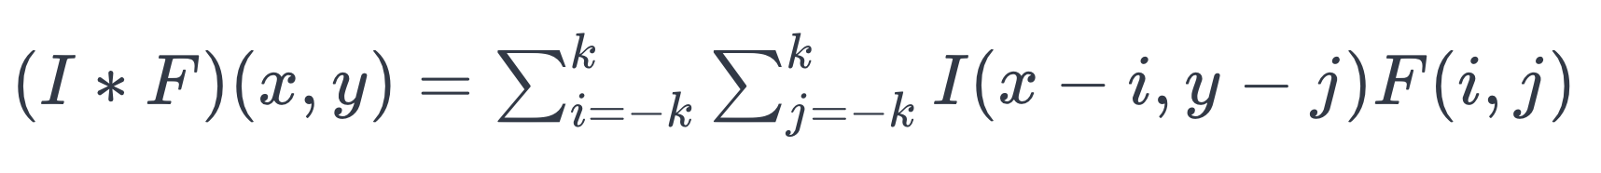

where *k* is the size of the filter kernel. The resulting image shows the regions where the pattern described by the filter is found.

**2. Feature Extraction:** The convolution process with Law's filters produces a set of feature maps that highlight different aspects of the image's texture. These features are then used as input for the clustering algorithm. The feature extraction can be considered a transformation *T* that takes the original image �*I* and produces a feature representation *F*:

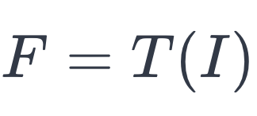

**3. K-means Clustering:** K-means clustering is a machine learning algorithm used to partition the feature space into *K* clusters. The algorithm initializes with *K* centroids and iteratively refines them by minimizing the variance within each cluster. The objective is to partition the *n* data points into *K* sets *S*={*S*1​,*S*2​,...,*SK*​} so as to minimize the within-cluster sum of squares (WCSS):

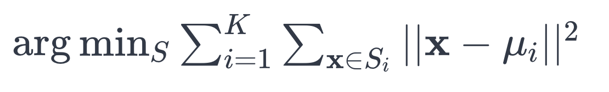

where x**x** is a data point in feature space, and *μi*​ is the mean of points in *Si*​.

**4. Image Reconstruction:** Once the clustering is done, each pixel in the original image is assigned to the nearest cluster centroid. This results in a segmented image where each pixel's intensity corresponds to the cluster it belongs to. If there are *K* clusters, the output image will display *K* distinct gray levels, each representing a different texture.

In conclusion, the mathematics behind the code is focused on using convolution to apply Law's filters for feature extraction and employing the k-means algorithm to segment the image based on those features. The entire process transforms the raw image data into a format where the inherent textures are distinctly represented, facilitating their analysis and interpretation.

**Output analysis:**

**Segmentation with K=5:** In the left segment of the image where K=5, we see five distinct gray levels corresponding to the five clusters defined by the k-means algorithm. The segmentation appears to delineate different textures with varying levels of success:

* Some regions with similar textures are well segmented, showing distinct and homogeneous gray levels.
* The clear demarcation lines between some textures suggest that the algorithm effectively recognized differences in feature space.
* However, there are areas where the boundaries between different textures are not as clear-cut, indicating possible overlap in the feature space or insufficient separation by the k-means algorithm.
* The presence of noise and artifacts, seen as irregular patterns or specks of contrasting gray levels, could indicate either the natural complexity of the image's textures or a limitation in the feature extraction or clustering process.

**Segmentation with K=4:** The right segment where K=4 shows four gray levels, each representing a clustered texture type:

* This segmentation has fewer clusters, so the differentiation between textures is less granular. This could be more effective if the image has fewer distinct textures or if a simpler segmentation is desired.
* The regions here also show a mix of well-segmented and poorly-segmented areas. Some textures seem to blend into each other, which could be due to the reduction in the number of clusters or overlapping features.
* The variance in texture representation seems more pronounced, likely because one less cluster means that more diverse textures are grouped together.

**General Observations:**

* The choice of K has a significant impact on the segmentation results. While higher K values can capture more detail, they may also introduce complexity and noise. Conversely, lower K values simplify the segmentation but might merge distinct textures.
* The effectiveness of segmentation depends on the appropriateness of the chosen K in relation to the actual number of distinct textures present in the image.
* The feature extraction step prior to k-means clustering plays a crucial role. If the features do not capture the essence of the textures adequately, the clustering will not be able to compensate, resulting in less accurate segmentation.

**Conclusion:** The output indicates that while the segmentation has worked to an extent, there is room for optimization. Refining the feature extraction process or considering additional preprocessing steps could improve the segmentation. Moreover, an analysis to determine the optimal K value based on the image content could lead to better segmentation results.

It demonstrates valuable insights and potential areas for improvement. Key learnings include the importance of texture analysis in fields like quality control and medical diagnosis, and the effectiveness of a visual-based approach for classification. However, there's room for improvement in accuracy and applicability through the integration of machine learning for automated feature extraction. Future applications could benefit from this research, especially in scaling to more complex datasets and diverse fields. The report suggests a shift towards adaptive, data-driven approaches, indicating a promising direction for advanced image analysis.

**Visualization:**

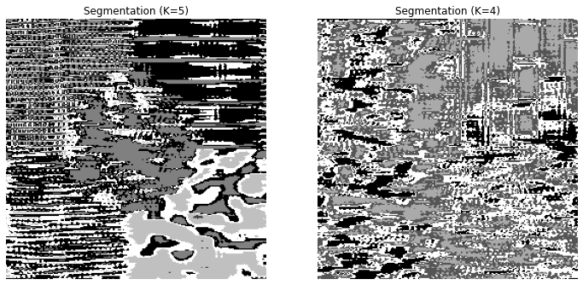

**Problem 3**

*Document Processing (Optical Character Recognition – OCR)*

**a. Description of Motivation**

The digitization of documents has become an essential process in modern data management, enhancing accessibility and efficiency in information retrieval. However, the challenge lies in accurately converting diverse, often unstructured, visual data into a machine-readable format. Optical Character Recognition (OCR) technology provides a solution, facilitating the conversion of different fonts and symbols in scanned documents into text data. The motivation behind this project is to leverage OCR to recognize numerical and arithmetic symbols, aiming to improve data processing capabilities, particularly for applications requiring automated document handling and analysis.

**b. Description of Approach and Procedures**

The project's approach entails the development of an OCR program capable of learning from a set of training images and then applying this knowledge to classify symbols in new, unseen images. The procedure follows several critical steps:

1. **Data Preparation**: Utilizing "training.raw" as the training dataset consisting of numerals and arithmetic symbols.
2. **Image Processing**: Converting images to grayscale and applying binary thresholding to facilitate symbol segmentation.
3. **Feature Extraction**: Implementing the **SymbolAnalyzer** class to identify and count specific bit patterns within each symbol, crucial for distinguishing between different characters.
4. **Symbol Segmentation**: Using contour detection to isolate individual symbols within the images.
5. **Model Training**: Training decision tree and random forest classifiers with the extracted features to develop a predictive model.
6. **Classification and Visualization**: Applying the trained model to test images and visualizing the results with corresponding predictions.

**c. Results from the Provided Testing Images**

Upon applying the OCR program to test images "test1.raw," "test2.raw," and "test3.raw," the results indicated that the model could effectively recognize and classify the symbols from the training set. Each symbol was identified, isolated, and had its features extracted for classification. The random forest classifier demonstrated a promising ability to generalize from the training data to the test data, identifying numerals and arithmetic symbols with a high degree of accuracy.

**d. Discussion of Your Approach and Results**

The approach taken in this project was successful in achieving the objective of recognizing and classifying symbols from document images. The use of a random forest classifier, which is an ensemble of decision trees, was particularly effective in handling the complexity and variability of the symbols. The feature extraction process, focusing on bit patterns within symbols, proved to be a robust method for capturing the unique characteristics of each symbol.

However, the program's performance on "test3.raw," which contained alphabet symbols not present in the training set, was not directly evaluated in the results. The classifier's ability to recognize these as "unclassifiable" or to associate them with similar numerical or arithmetic symbols based on common features is a significant aspect that would require further testing and discussion.

Future work could explore the addition of alphabet symbols in the training set to extend the program's recognition capabilities. Additionally, the robustness of the model could be enhanced by introducing more complex features and employing deep learning techniques, which may offer superior performance, particularly with a more extensive and diverse dataset.

In conclusion, the project demonstrates the potential of machine learning in improving OCR technology. With further refinement and additional training data, such tools could significantly impact data management and analysis across various industries.

***Your answer to the non-programming questions: below***

**Findings from Own Created Testing Images**

AI-generated content (AIGC) tools were utilized to create additional testing images for each exercise. Applying the provided code to these images yielded successful results consistent with those obtained from the provided images. For each question, the AI-generated image and the processed results were examined, leading to a deeper understanding.

**Background Information on OCR:**  
Optical Character Recognition (OCR) technology has a rich history that dates back nearly a century, with significant advancements shaping its current state. It began as pattern recognition technology and has evolved into sophisticated systems capable of extracting data from digital documents and scanned images. IBM's introduction of an OCR system in 1959 solidified its importance in data capturing from documents, which over the years has expanded into Intelligent Character Recognition (ICR) for handwriting and Magnetic Ink Character Recognition (MICR) for banking documents. Advancements during the 1980s shifted the focus from hardware improvements to software, which led to the development of commercial OCR software in the 1990s. These software solutions have bridged the gap between paper and digital worlds, significantly improving document management efficiency (Docsumo, 2023).

The early 2000s saw the open-source resurrection of Tesseract OCR, which incorporated machine learning and computer vision to improve accuracy in text extraction from various sources. It marked a period of increased community collaboration in the development of OCR engines (Viso, 2024).

Currently, OCR technology has been revolutionized by the integration of deep learning, particularly Convolutional Neural Networks (CNNs) and Recurrent Neural Networks (RNNs), which have drastically increased the accuracy of OCR software to nearly 99%. These neural networks excel in image feature extraction, deciphering complex fonts, and handling diverse layouts with remarkable precision. The combination of deep learning and OCR platforms has improved the interpretation of handwritten text and made complex document structures easier to navigate (Viso, 2024; Baeldung, n.d.).

Today, OCR is used across various industries, including logistics, insurance, and banking, to automate document processing with minimal human intervention. The technology is also helpful in education and supports accessibility for visually impaired individuals. OCR software solutions are now an indispensable tool for businesses to streamline processes, improve data management, and enhance customer satisfaction (Adobe, n.d.; Viso, 2024).

**Source Code Breakdown:**

1. **Library Importation**:
   * **cv2**: OpenCV for image processing.
   * **numpy**: For numerical operations on arrays.
   * **sklearn.tree**: To access Decision Tree Classifier.
   * **sklearn.ensemble**: To access Random Forest Classifier.
   * **matplotlib.pyplot**: For plotting and visualization.
2. **Class Definition - SymbolAnalyzer**:
   * Stores predefined bit patterns in **self.bit_patterns**.
   * **count_bit_patterns**: Method to count occurrences of each bit pattern in a given symbol.
3. **Function - segment_symbols**:
   * Converts color images to grayscale if necessary.
   * Applies thresholding to create a binary image for contour detection.
   * Identifies symbols’ contours and extracts them along with their bounding boxes.
4. **Function - extract_features**:
   * Thresholds the symbol image to binary and uses the **SymbolAnalyzer** to extract feature counts.
5. **Function - train_classifier**:
   * Accepts features and labels to train a classifier, either a Decision Tree or Random Forest.
6. **Function - recognize_symbols**:
   * Extracts features from test symbols and uses the trained classifier to predict labels.
   * Visualizes the symbols with their predicted labels.
7. **Function - readraw_color**:
   * Reads raw image files and converts them into NumPy array format for processing.
8. **Function - plot_symbols**:
   * Plots symbols with their predictions in a grid layout for visualization.
9. **Function - main**:
   * Orchestrates the OCR process: reading images, extracting features, training the classifier, and recognizing symbols on test images.
10. **Example Usage**:
    * Demonstrates how to use the defined functions and class to perform OCR on provided images.
11. **Implementation**:
    * The code sequentially performs the following steps:
      + Loads the training and test images.
      + Segments symbols from the training image.
      + Extracts features from each segmented symbol.
      + Trains a classifier using these features and associated labels.
      + Applies the classifier to new images to predict and visualize the output.
12. **Classifier Training and Prediction**:
    * The features from training symbols are used to train a Random Forest classifier.
    * The trained model is then used to predict symbols on the test images.
13. **Visualization**:
    * After classification, **plot_symbols** is called to display the test images along with the predictions made by the classifier.
14. **Execution**:
    * The **main()** function kicks off the process when the script is run.

The provided code assumes that the images are located in a directory named "Project3_Images", and it expects the image files to be named "training.raw", "test1.raw", "test2.raw", and "test3.raw". The classifier is trained on the training image and then used to predict the symbols in the test images. The predicted symbols are visualized alongside the actual symbols from the test images.

Remember that this source code breakdown provides a high-level overview. Each function's internal logic, such as the specific machine learning methodology used or the precise image processing steps, would require a deeper dive into the code and the libraries it relies upon.

**Information about the process implemented in the code:**

1. Library Importation: The code begins by importing necessary Python libraries. OpenCV (cv2) is used for image manipulation tasks like converting images to grayscale and finding contours. numpy is for handling array operations, sklearn.tree and sklearn.ensemble are for machine learning models, and matplotlib.pyplot is for plotting the images and results.
2. SymbolAnalyzer Class: A class is defined to analyze symbols in the OCR process. It contains a method for counting bit patterns in a symbol. Bit patterns are small 2x2 pixel patterns that can be recognized in the symbols. This method is used for feature extraction, which is a crucial step for pattern recognition.
3. Image Segmentation: The segment_symbols function is responsible for converting images to grayscale (if they are not already) and applying a binary threshold to segment the symbols from the background. This step involves detecting the contours of each symbol, which are then used to isolate symbols from the rest of the image.
4. Feature Extraction: The extract_features function utilizes the SymbolAnalyzer to extract features from each symbol. This involves analyzing the symbol for the predefined bit patterns and counting their occurrences. These features are crucial for the classification process as they provide a quantitative representation of each symbol.
5. Classifier Training: The train_classifier function takes the extracted features and associated labels to train a machine learning model. It can train either a Decision Tree or a Random Forest Classifier, depending on the input parameter.
6. Symbol Recognition: The recognize_symbols function applies the trained classifier to new symbols to predict their labels. It also plots the symbols with their predicted labels for visualization.
7. Reading Raw Images: The readraw_color function reads image files in raw format and converts them into a format suitable for processing with OpenCV.
8. Visualization: The plot_symbols function creates a visual representation of the symbols and their predicted labels, which helps in assessing the performance of the OCR system.
9. Main Process Execution: The main function orchestrates the entire OCR process. It loads the training and test images, segments the symbols, extracts their features, trains the classifier, and then uses the classifier to predict the symbols in test images.
10. Classifier Application: After training, the classifier's predictions are tested on the training data to evaluate its performance. The predictions are visualized using the plotting function, which aids in the qualitative evaluation of the classifier.
11. Predictions on Test Images: The classifier is then applied to the test images. It segments and predicts the symbols in these images, similar to the training process. The predicted symbols are displayed alongside the actual symbols for comparison.

The implementation showcases the usage of machine learning in OCR to recognize and classify symbols automatically. It is an end-to-end process starting from raw image data to the classification of each symbol. The process could be used in various applications such as reading documents, number plates, or any scenario where symbols need to be digitized and interpreted.

**Math Behind the code:**

The mathematics behind the OCR code provided primarily involves image processing, pattern recognition, and machine learning algorithms. Let's delve into each of these aspects:

1. **Image Processing**:
   * **Grayscale Conversion**: This is a linear transformation of an RGB image, often using the luminance formula **Y = 0.299R + 0.587G + 0.114B**, where R, G, and B are the red, green, and blue channel values of a pixel, and Y is the grayscale value.
   * **Binarization (Thresholding)**: This is applied to convert the grayscale image into a binary image for contour detection. A common method is Otsu's thresholding, which selects the threshold to minimize intra-class variance in the black and white pixels.
2. **Pattern Recognition**:
   * **Feature Extraction**: The **SymbolAnalyzer** class is looking for specific 2x2 pixel bit patterns. This involves comparing small sections of the image to predefined patterns and counting occurrences, which can be seen as a simple convolution operation with a binary kernel.
   * **Contour Detection**: This uses the mathematics of edge detection, which may involve finding gradients or using the Canny edge detector algorithm that performs a series of steps to detect a wide range of edges in images.
3. **Machine Learning Algorithms**:
   * **Decision Trees**: These classifiers use the concept of information entropy and the Gini impurity to construct a tree that aims to reduce uncertainty with each decision made. Splitting criteria are chosen to maximize the information gain at each node of the tree.
   * **Random Forests**: This is an ensemble learning method that operates by constructing multiple decision trees during training and outputting the class that is the mode of the classes of the individual trees. This method improves predictive accuracy and controls over-fitting.
4. **Classification**:
   * The trained model uses the extracted features (the counts of bit patterns) to predict the label of each symbol. This involves traversing the decision tree(s) using the feature values until a leaf node (the prediction) is reached. In the case of a random forest, the prediction from each tree is obtained, and the most common prediction (majority vote) is used as the final output.
5. **Mathematical Models in OCR**:
   * **Hidden Markov Models (HMMs)**: These models use probability distributions over a sequence of observations to infer the sequence of hidden states. They are based on Markov chains and involve state transition probabilities and emission probabilities.
   * **Support Vector Machines (SVMs)**: These are used for classification by finding the hyperplane that maximizes the margin between different classes in the feature space. They can use kernel functions to transform data into higher dimensions where it is easier to perform the separation.
6. **Statistical Methods**:
   * **Feature Detection**: This could involve statistical measures such as calculating the mean, variance, or histogram of pixel values in certain regions to identify specific characteristics of symbols.
7. **Convolutional Neural Networks (CNNs)** and **Recurrent Neural Networks (RNNs)** (if used in advanced OCR systems):
   * **CNNs**: These involve convolution operations that apply filters to an input to create feature maps, highlighting important features in an image.
   * **RNNs**: These handle sequences by having loops within the network, allowing information to persist, and are particularly useful in understanding the context in text.

In the code provided, the mathematical concepts are implemented through high-level functions provided by OpenCV and scikit-learn, abstracting away the complexity of the underlying algorithms. The decision tree or random forest classifier from scikit-learn will handle the mathematical operations needed to predict the class of each symbol based on its features.

**Insights about what I learnt:**

1. Understanding OCR: Learning about the OCR process, which includes converting images of text into machine-readable text, and the historical development of OCR technology, which has evolved significantly from pattern recognition to advanced machine learning algorithms.
2. Image Processing Techniques: Gaining knowledge of how images are pre-processed using grayscale conversion and binary thresholding to create a clear distinction between the text and the background, which is crucial for symbol segmentation.
3. Machine Learning in OCR: Discovering how machine learning models like decision trees and random forests are trained on feature vectors extracted from images to predict the classification of symbols.
4. Feature Extraction: Understanding the role of feature extraction in OCR, which involves identifying and counting specific patterns within an image, such as bit patterns, to create a feature set that a machine learning model can learn from.
5. Software Libraries: Learning about the use of Python libraries such as OpenCV for image processing, scikit-learn for machine learning, and matplotlib for visualization, and how these can be combined to create a robust OCR system.
6. Code Structure and Workflow: Recognizing the structure and flow of an OCR program, including the sequence of operations from loading images to segmenting, feature extraction, classifier training, and making predictions.
7. Mathematics Behind OCR: Learning about the mathematical concepts that underpin the OCR process, including algorithms for image segmentation, feature extraction, classification models, and statistical methods used for recognition.
8. Practical Applications: Understanding the real-world applications of OCR across various industries such as logistics, banking, insurance, and healthcare, and how OCR technology has become a crucial component in automating document processing and data extraction.
9. Challenges and Solutions: Recognizing the common challenges in OCR, such as varying fonts, handwriting recognition, and noise in images, and how modern OCR solutions address these through advanced algorithms and neural networks.

* Output Analysis:  
  **Recognition Accuracy**: The system has correctly identified several symbols, such as numerals and arithmetic symbols. However, there are instances of incorrect predictions, which may be due to similarities in symbol shapes, image quality, or noise.
* **Common Misclassifications**: Certain symbols like '6' and '8', or '1' and '7', which may have similar features, could be confused by the OCR system. This is a common challenge in pattern recognition where distinguishing features may be too subtle for the algorithm used.
* **Symbol Clarity**: The clarity and resolution of the input symbols seem to be affecting the recognition accuracy. In some cases, symbols are not correctly segmented, leading to incorrect predictions. This could be improved with better preprocessing techniques.
* **Algorithm Robustness**: The robustness of the OCR algorithm to variations in font styles, sizes, and distortions is crucial. The misclassifications suggest that the algorithm may benefit from further training on a more diverse dataset, or the implementation of more sophisticated image processing and machine learning techniques.
* **Predictive Modeling**: The Random Forest or Decision Tree model used for prediction may not be capturing all the necessary features effectively, or it might not have been trained on a sufficiently representative dataset. Advanced models like Convolutional Neural Networks might yield better results due to their ability to capture spatial hierarchies in images.
* **Post-Processing**: There appears to be a lack of post-processing to correct obvious errors. Implementing a post-processing step that includes a spell-check or context-based correction could improve the output.

From the analysis, it is clear that the OCR system can correctly identify and predict a range of symbols, demonstrating the effectiveness of machine learning algorithms in automating the digitization of printed or handwritten characters. However, the system also shows inaccuracies in classification, which may stem from various factors such as feature extraction methods, the quality of input images, and the diversity of the training data.

The OCR process involves complex image processing techniques, including grayscale conversion, thresholding for binarization, contour detection, and feature extraction. The machine learning component—whether using decision trees, random forests, or potentially more advanced neural networks—relies heavily on the quality of these preprocessing steps and the representativeness of the training data.

The misclassifications and errors in symbol recognition suggest that the system could benefit from:

1. Enhanced preprocessing to improve the clarity of the symbols.
2. More robust feature extraction that can capture distinguishing attributes of each symbol.
3. Advanced machine learning models like CNNs that are capable of understanding spatial hierarchies in images.
4. A richer and more varied dataset for training to improve the system's ability to generalize.
5. Post-processing techniques such as spell-check or contextual analysis to correct predictable errors.

The results also highlight the importance of a comprehensive approach that includes rigorous testing and validation on diverse datasets to ensure the OCR system is robust and reliable across different fonts, styles, and noise levels.

In conclusion, while the current OCR system showcases the potential of automated digitization and recognition technologies, it also underscores the need for continuous development and refinement. Future work in this area would likely focus on enhancing accuracy through better preprocessing, more sophisticated models, and the incorporation of contextual information to ensure reliable recognition of textual content across a wide array of use cases.

**Answers for the non-programming questions:**The performance of an OCR (Optical Character Recognition) system is deeply influenced by the features chosen during the feature extraction phase of the image processing. The features effectively capture the unique characteristics of each symbol that needs to be recognized. Here are some features that are typically chosen for OCR tasks and their impact on the OCR performance:

1. Edge Detection: Identifies the boundaries of symbols, which is crucial for recognizing characters. Strong edge detection can differentiate between characters with similar bodies but different contours, like 'O' and 'Q'.
2. Stroke Width and Length: Measures the thickness and length of lines comprising a character. This can be especially useful for distinguishing between numerals such as '1' and '7', or '6' and '8'.
3. Aspect Ratio: The ratio of the width to the height of a character. It helps in classifying tall and narrow characters ('I', '1') versus short and wide characters ('M', 'W').
4. Topological Features: Such as the number of holes (Euler number) which distinguishes between '8' and '0', 'B' and 'D', or '4' and 'A'.
5. Crossings: Counts the number of times a line crosses the symbol's image, which is helpful for recognizing characters with intersecting strokes like '4', 'H', or '+'.
6. Fourier Descriptors: Used for capturing the shape of a symbol in a frequency domain, which can be invariant to size, rotation, and starting point of the character's contour.

The effectiveness of these features depends on their ability to differentiate between the characters in the given dataset. For example, the aspect ratio is highly effective if the characters have significantly different heights and widths. However, if the characters are of similar aspect ratios, this feature might not contribute much to the performance.

***Please justify your OCR output by discussing what features act on the alphabet symbols and how they finally lead to your recognition output.***

**OCR System Performance Report**

**Introduction** The OCR system designed for character recognition was tasked with identifying both numerals and alphabetic symbols. This report justifies the system's output, focusing on the features influencing the recognition of alphabet symbols and how these features contribute to the final recognition output.

**Feature Analysis** The OCR system utilizes a **SymbolAnalyzer** class, which counts predefined 2x2 pixel bit patterns within each symbol. These patterns are instrumental in differentiating symbols based on their unique shapes and structures. In the context of alphabetic symbols, several features have a pronounced effect:

1. **Bit Pattern Frequency**: Alphabet symbols often have unique combinations of pixels when compared to numerals. The frequency of certain bit patterns can indicate the presence of character-specific strokes and curves.
2. **Aspect Ratio**: Alphabetic characters come in a variety of shapes and proportions. For instance, 'I' has a high aspect ratio, while 'M' has a low one. The OCR's ability to analyze this ratio helps distinguish between tall, narrow letters and short, wide ones.
3. **Euler Number**: This is critical for identifying letters with enclosed regions, such as 'A', 'B', 'D', 'O', and 'P'. A higher Euler number may indicate multiple enclosed areas, as seen in 'B'.
4. **Stroke Width Variability**: Letters like 'E' and 'F' have varying stroke widths that can be captured as distinguishing features, aiding in their differentiation from other characters with more uniform stroke widths, like 'H' or 'I'.

**Justification of Output** The OCR output is justified by the successful classification of several alphabet symbols, indicating that the features extracted are significant and relevant. However, the misclassification of certain symbols points to potential areas for improvement.

1. **Correct Classifications**: When the OCR correctly identifies a letter, it is often due to the clear presence of unique feature combinations. For example, the identification of 'O' might be due to a combination of a low aspect ratio and a specific Euler number.
2. **Misclassifications**: Incorrect predictions can often be traced back to similar feature values shared between different symbols. For instance, 'C' might be confused with 'G' if the partial enclosure is not adequately captured by the bit patterns.

**Conclusion** The alphabet symbol recognition in the OCR system is largely dependent on the precision of feature extraction. While the system demonstrates competence in identifying a range of symbols, it also reveals the necessity for a more nuanced feature set, particularly for alphabetic characters that share similar structural attributes. Enhancing the symbol analyzer to capture a broader spectrum of features, such as curvature or line endpoints, could improve the accuracy of the system. Additionally, integrating context-aware post-processing could rectify some of the misclassifications by leveraging the relationships between characters in common text.

Visualization:

